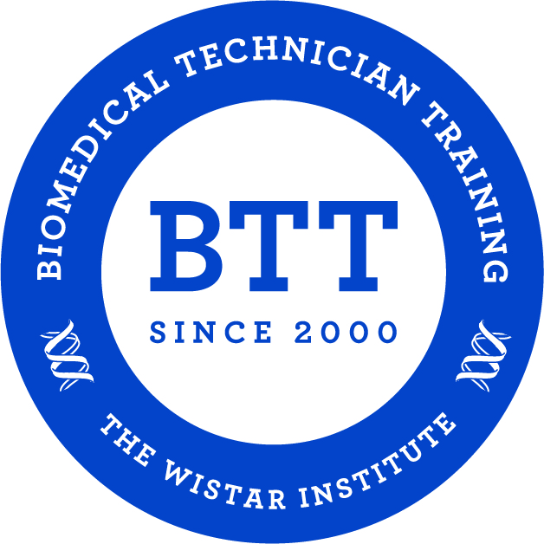
Biomedical Technician Training Program
Application

Due Date: Friday, December 16, 2021

Please complete the following information and attach a copy of your transcript(s). Two letters of recommendation are also needed from a science instructor and another instructor, however, this may be attached or sent separately by the instructor to Dr. Dominic Salerno at dsalerno@ccp.edu.

Name: ___________________________________________________________________________

CCP J#: J_________________________________________________________________________

Address: ________________________________________________________________________

___________________________________________________________________________________

Phone: __________________________________________________________________________

Email: ___________________________________________________________________________

Please email your application (and accompanying materials) to:

dsalerno@ccp.edu

Subject: Biomedical Technician Training Program

Remember the Spring 2021 application due date is
Friday, December 16th, 2021!

